

Faculty of Applied Sciences  
Bachelor of Science in Computing

**COMP321-322 Project Work  
Plan**Academic Year 2022/23 Semester 2

|  |  |
| --- | --- |
| Online Shopping Mall | |
|  |  |
| Group Number: | 6 |
| Student ID: | P2010411  P2010556  P2010562 |
|  |
| Student Name: | Grant, Jing Yulong  Polo, Liu Runrong  Veronica, Chen Lingxiao |
|  |
|  |
|  |
|  |  |

**Table of Contents**

1. Introduction 3

2. Project Scope 3

a) Product Scope (Functional Requirements) 3

Basic Features 3

Advanced Features 5

b) Process Scope 5

Tasks 5

3. Schedule Plan 6

WBS and Gantt Chart 6

4. Job Allocation 9

# Introduction

Nowadays, technology plays a crucial role in our daily lives. Thanks to the benefits of technology, a new form of business appeared, known as E-commerce (electronic commerce). E-commerce is buying and selling goods and services or transmitting funds or data over an electronic network, primarily the internet. This project aims at creating an application providing an e-commerce service on mobile phones. In detail, customers will enjoy a shopping experience online, and vendors display their products in a manner that is easy for potential customers to select and make purchases.

# Project Scope

## Product Scope (Functional Requirements)

### Basic Features

(A1) A customer may browse products in a list of products. The list shows basic information of products, including product name, brand, price and a thumbnail image. Each product belongs to one of the pre-defined brands. (You can also use category instead of brand).

(A2) The product list supports paging. The customer can navigate the product list by ‘page up’, ‘page down’ and jumping to a specific page. Paging works properly after applying a filter or sorting as listed below.

(A3) The customer can filter the product list by brand. They can also list products of all brands.

(A4) The customer may filter the product list by searching keywords in the product name. This function work correctly with the brand filter.

(A6) The customer may select a product in the product list to go to the product detail page. The product detail page shows information for one product, which includes the product name, brand, price and a thumbnail image. In addition, the product detail page also shows detail description as a list of at least two properties. For example, the product detail page for a book may show authors, ISBN, publisher, release date and number of pages.

(B1) A customer may register a new account. They have to provide full name, email address, password and shipping address. After registration, the user is logged in automatically.

(B2) A customer may log in and log out, and the interface shows the name of the current user. The product list and product detail page are accessible to customers without login. On the other hand, the shopping cart and purchase tracking are only accessible after login.

(C1) The customer adds a product to his/her shopping cart by clicking a button in the product detail page. The quantity to buy is assumed to be 1. The items in shopping cart are persisted across user sessions. Next time the customer logs in, they can still see the items in the shopping cart.

(C2) The customer can list the products in his/her shopping cart in a shopping cart page. In this page, the entry for each product shows the product name, price and the quantity to buy. The page also shows the total order amount (i.e., how much the customer has to pay in total) in the shopping cart. The customer can click an item in the shopping cart to go to the product detail page of the entry.

(C3) The customer can press a button in the shopping cart page to check out all items in the shopping cart. This action creates a purchase order with a newly allocated unique P.O. number, and clears the content of the cart. After checkout, the system shows the purchase order detail page of the newly created purchase order. (Refer to requirement D3).

(C5) The customer can remove an item from the shopping cart.

(D1) The purchase tracking page lists the purchase orders that the customer has placed. This page shows the following for each purchase order: the P.O. number, the purchase date, the total order amount and the purchase order status. The purchase orders are displayed in reverse chronological order of purchase date. When the customer clicks an entry in the list, they can see the detail in a purchase order detail page.

(D2) The customer can filter the list of purchase orders in two ways. First, the page only shows ‘current purchases’ with status ‘pending’ and ‘hold’. Second, the page only shows ‘past purchases’ with status ‘shipped’ and ‘cancelled’.

(D3) The purchase order detail page shows the P.O. number, the purchase date, the customer’s name, the shipping address, the total order amount and the purchase order status. If the order is shipped, this page shows the shipment date. If the order is cancelled, the page shows the order cancel date and who (customer or vendor) cancelled the order. The page also includes, for each product in the purchase order, the product name, the quantity, the unit price and the subtotal.

(E1) The vendor may browse the product catalog in an interface similar to product list for customers. (Refer to requirements A1, A2, A3 and A6). The vendor is not a customer, and no shopping cart or ‘add to cart’ button should be shown.

(E2) The vendor can find products by searching keywords in product names. They can also find a specific product by entering a unique product ID.

(E3) The vendor may add a new product to the catalog. The vendor enters basic information of the product, including product name, brand, price and a thumbnail image. They can enter detail information.

(F1) The purchase order list page lists purchase orders received by the application. It shows the P.O. numbers, purchase dates, customer names, total order amounts and purchase order status. The purchase orders are sorted in descending order of purchase date (i.e., newest first). The vendor can click an entry to open a purchase order processing page.

(F2) The vendor can filter the purchase order list in three ways. They can show only the ‘pending orders’ (with status ‘pending’). They can show only the ‘orders on hold’ (with status ‘hold’). Finally, the vendor can select to show ‘past orders’ (with status ‘shipped’ or ‘cancelled’).

(F3) The purchase order processing page shows similar information as the purchase order detail page (refer to requirement D3). In addition, the vendor can click a button to ship a purchase order. This action changes the status of the purchase order from ‘pending’ to ‘shipped’ and starts the shipping process.

(F4) The vendor can enter a P.O. number to view and process a specific purchase order.

### Advanced Features

(Z0) Develop a mobile app as the frontend of the system. The mobile app should communicate with the server backend through a Web API. You have to design and implement both the frontend and the backend.

## Process Scope

## Tasks

1. Form project team
2. Select project leader
3. Elicit requirements
4. Analyse the functional requirements
5. Background study on similar projects about developing an Online Shopping Mall on mobile phone
6. Develop project work plan
7. Design the overall software architecture (system design)
8. Design abstract models of the system
9. Design the databases
10. Design graphical interfaces on mobile phone
11. Develop interface templates for the sponsor to review
12. Code the database for server-side modules
13. Code the server-side modules
14. Code the individual graphical user interface for the site (products page, product detail page, related account management page, shopping cart page, purchase tracking page, purchase order detail page, product catalogue page, purchase order list page, purchase order processing page)
15. Code and configure the client-side modules
16. Integrate the server-side modules and the pages
17. Expert reviews
18. Usability testing
19. UAT testing
20. Deploy Server-side programs on a private server
21. Promote and deliver mobile apps
22. Develop tips for first-time users of graphical user interface
23. Create step-by-step video guidance for customers and vendors

# Schedule Plan

## WBS and Gantt Chart

|  |  |  |  |  |  |
| --- | --- | --- | --- | --- | --- |
| Task Name | Duration | Start | Finish | Predecessors | Resource Names |
| **Online Shopping Mall** | **109 d** | **2023/1/6** | **2023/4/24** |  |  |
| **Initiating** | **4 d** | **2023/1/6** | **2023/1/9** |  |  |
| Form projejct team | 1 d | 2023/1/6 | 2023/1/6 |  | Grant,  Polo,  Veronica |
| Submit the group list | 0 d | 2023/1/6 | 2023/1/6 | 3 | Grant,  Polo,  Veronica |
| Select project leader | 1 d | 2023/1/6 | 2023/1/6 |  | Grant |
| Elicit requirements | 1 d | 2023/1/7 | 2023/1/7 | 3,5 | Grant,  Polo,  Veronica |
| **Analysis** | **10 d** | **2023/1/8** | **2023/1/17** |  |  |
| Analyze the functional requirements | 6 d | 2023/1/8 | 2023/1/13 | 6 | Grant,  Polo,  Veronica |
| Requirement specification | 0 d | 2023/1/13 | 2023/1/13 |  |  |
| Background study on similar projects about developing an Online Shopping Mall on mobile phone | 6 d | 2023/1/8 | 2023/1/13 | 6 | Grant,  Polo,  Veronica |
| Develop project work plan | 4 d | 2023/1/14 | 2023/1/17 | 8,10 | Grant,  Polo,  Veronica |
| Submit project work plan | 0 d | 2023/1/17 | 2023/1/17 | 11 | Polo,  Veronica,  Grant |
| **Design** | **33 d** | **2023/1/18** | **2023/2/20** |  |  |
| Design the overall software architecture (system design) | 5 d | 2023/1/18 | 2023/1/22 | 11 | Grant,  Polo,  Veronica |
| Design abstract models of the system | 5 d | 2023/1/18 | 2023/1/22 | 11 | Grant,  Polo,  Veronica |
| Design the databases | 5 d | 2023/1/23 | 2023/1/27 | 14,15 | Grant,  Polo,  Veronica |
| Design graphical interfaces on mobile phone | 9 d | 2023/1/18 | 2023/1/26 | 11 | Grant,  Polo,  Veronica |
| Develop interface templates for the sponsor to review | 5 d | 2023/1/27 | 2023/1/31 | 17 | Grant,  Polo,  Veronica |
| Completion of design | 0 d | 2023/1/31 | 2023/1/31 |  |  |
| Submit progress check form and final Gantt chart | 0 d | 2023/2/20 | 2023/2/20 |  | Grant,  Polo,  Veronica |
| **Implementation** | **58 d** | **2023/1/28** | **2023/3/27** |  |  |
| Code the database for server-side modules | 21 d | 2023/1/28 | 2023/2/17 | 16 | Grant,  Polo,  Veronica |
| Code the server-side modules | 21 d | 2023/2/18 | 2023/3/10 | 22 | Grant,  Polo,  Veronica |
| Code the individual graphical user interface for the site | 21 d | 2023/2/1 | 2023/2/21 | 18 | Grant,  Polo,  Veronica |
| Code and configure the client-side modules | 10 d | 2023/3/11 | 2023/3/20 | 23 |  |
| Demo all basic requirements and submit a draft project report | 0 d | 2023/3/27 | 2023/3/27 |  | Grant,  Polo,  Veronica |
| **Integration** | **10 d** | **2023/3/21** | **2023/3/30** |  |  |
| Integrate the server-side modules and the pages | 10 d | 2023/3/21 | 2023/3/30 | 24,25 | Grant,  Polo,  Veronica |
| **Testing** | **17 d** | **2023/3/31** | **2023/4/17** |  |  |
| Expert reviews | 3 d | 2023/3/31 | 2023/4/2 | 28 | Veronica |
| Usability testing | 3 d | 2023/4/3 | 2023/4/5 | 30 | Grant,  Polo,  Veronica |
| UAT testing | 3 d | 2023/4/6 | 2023/4/8 | 31 | Grant,  Polo,  Veronica |
| Demo advanced requirements and submit the final report | 0 d | 2023/4/17 | 2023/4/17 |  | Grant,  Polo,  Veronica |
| **Deployment** | **16 d** | **2023/4/9** | **2023/4/24** |  |  |
| Deploy Server-side programs on a private server | 5 d | 2023/4/9 | 2023/4/13 | 32 | Grant,  Polo,  Veronica |
| Deliver the mobile app | 0 d | 2023/4/14 | 2023/4/14 | 35 |  |
| Promote and deliver mobile apps | 2 d | 2023/4/14 | 2023/4/15 | 35 | Grant,  Polo,  Veronica |
| Develop tips for first-time users of graphical user interface | 3 d | 2023/4/9 | 2023/4/11 | 32 | Grant,  Polo,  Veronica |
| Create step-by-step video guidance for customers and vendors | 7 d | 2023/4/9 | 2023/4/15 | 32 | Polo |
| Final presentation and demo | 1 d | 2023/4/24 | 2023/4/24 | 38,39 | Grant,  Polo,  Veronica |

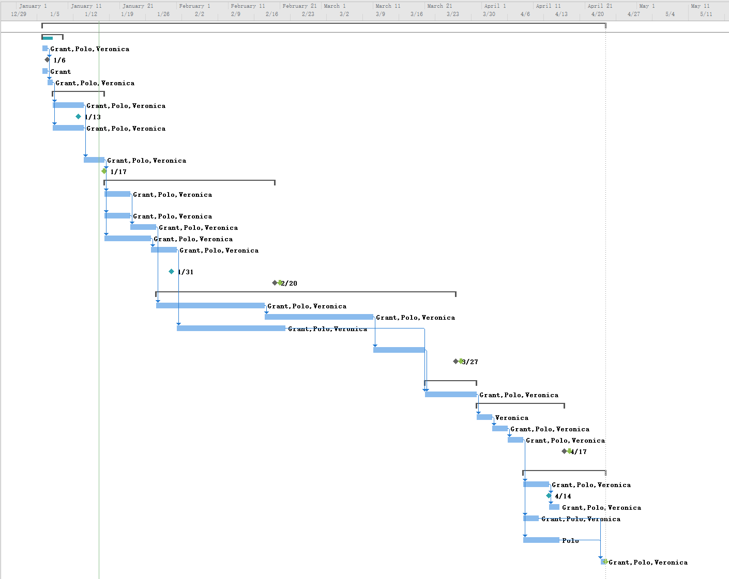

# Job Allocation

Responsibility Assignment Matrix (RAM)



R = responsibility

A = accountability, only one “A” per task

C = consultation

I = informed